**REGRESSION BASED MENTAL FATIGUE ESTIMATION**

**Abstract:**

The goal is to estimate the Mental fatigue generated in driver’s while driving for a time greater than a threshold. The eye activity and the reaction time of the driver was collected using a driving simulator in which subjects are instructed to follow a guiding car and should stop whenever the guiding car applies red tail lights as an indication to stop. Along with this the eye activity was recorded using an eye tracker from Tobiipro named Tobii Pro Eye Glasses 2 along with a virtual reality device. The mental fatigue while driving estimation with regression-based studies was achieved using this eye tracking data along with time as the label of fatigue generation. Here five regression models are used for this study and the performance of these models were compared. An index which is the logarithm of the ratio of Pearson’s correlation coefficient to the Mean squares error value (MSE) was proposed as a one of metric for evaluating the performance on Fatigue estimation and Dynamic Time Warping (DTW) method was used to measure the similarity between predicted Mental fatigue level using regression analysis and actual mental fatigue level. In this study, a Polynomial regression model with degree three has achieved the DTW value of 9.79E-12 and index value of 4.89416995 which corresponds to the coefficient of determination (R2) score of 100% for the test set. This defines the validity of the model and shows that it is highly practicable.

**Introduction:**

The purpose of this study is to construct a machine learning program to efficiently estimate the instantaneous degree of mental fatigue using eye tracking data features. Mental fatigue is a condition triggered by prolonged cognitive activity. It can happen when you expend too much mental effort on a project or task. Mental fatigue is a temporary condition in which one cannot maintain optimal cognitive performance (1). It can also be defined as a difficulty in initiation or continuation of tasks that one used to carry out. It is also a common symptom of various diseases and it can also be observed in persons with sound health as well. There are countless occupations today in which fatigued individuals routinely operate complex, high-risk systems (2). For example, worst nuclear disasters like Chernobyl power plant, the three-mile island and the EXXON Valdez oil spill in Alaska, and the Guantanamo bay air crash. There are a lot of well publicized and not well publicized disasters which took place due to fatigued operator (3). Analyses of crash data confirm that fatigue and inattention pose the greatest known risks to auto-mobile driver and passenger safety, surpassing all other known risks including alcohol consumption and secondary tasks such as mobile phone usage (4). The scenario of driving was considered for this study because in the majority of the cases mental fatigue has effects on the long run whereas in case of drivers, mental fatigue can result in severe accidents which can cause fatal injuries. Mental fatigue in drivers is a reason for occurring a large number of accidents which results in acute and in some cases fatal injuries. The number of accidents happening because of Mental fatigue in drivers due to prolonged monotonous driving is greater than the number of accidents due to alcohol or drugs (5). Accidents caused by driver's drowsiness behind the steering wheel have a high fatality rate because of the marked decline in the driver's abilities of perception, recognition, and vehicle control abilities while sleepy (6). So there is a large need of detecting mental fatigue while driving effectively and taking suitable protective measures for preventing accidents.

Fatigue estimation can be performed effectively with three main approaches i.e., Psychometrics, video and physical measurements. Psychometric approaches involve questionnaires answered by subjects at random intervals of time and based on these responses level of fatigue is estimated (7,8). But this method can often get biased by the nature of the subject, so this approach is not very much reliable. Video or Audio based measurements like facial expressions, changes in voice characteristics have also been used as a marker to estimate fatigue levels (9). Physiological measurements approach includes eye activity measures (10-12), heart beat rate, skin electric potential (13), and particularly using neurophysiological measurements like EOG (electrooculography), EEG (electroencephalography), and ECG (electrocardiography) for fatigue estimation (14-18). Since Brain is the location where mental fatigue develops and this will induce changes in physical characteristics like facial expressions and voice characteristics, so estimation of mental fatigue using eye tracking which originates at the brain will allow better and quick detection than that of video-based approach (19).

In this study, we have used regression models like Polynomial regression model, Support vector regression model, Partial least squares regression model, and Artificial neural network regression model to tackle the non-linear features which are associated with the mental fatigue regression and the features which are highly correlated with the fatigue level was identified using Pearson’s correlation coefficient, which was further used to effectively estimate the mental fatigue level in the subjects. Along with that a new metric was introduced to efficiently measure the accuracy of regression models used, logarithm of the ratio of Pearson’s correlation coefficient (r) to the Mean Squared Error (MSE) value. This metric can be used to measure the accuracy of the models in regression analysis. Since the r is in the range of -1 and +1 and MSE which is in the range of 0 to ∞, the model with best performance will have positive and small integers as index values as logarithm was used, which makes it better for comparison-based studies. Along with Index, Dynamic time warping was used to check the similarity between the estimated mental fatigue level and actual mental fatigue level and compared the types of DTW methods according to performance and time. In this study DTW was used to cross check the results obtained using Index as a metric. DTW values obtained also follow a similar trend followed by Index values and from this it was concluded that Index can be a better measure for regression analysis. By using DTW, performance of models was measured accurately. Since the data used in this study was eye tracking data with reaction time as a measure of mental fatigue level, this can induce a small difference between the actual fatigue level and fatigue level measured by reaction time. This is because eye tracking data reflects the change in mental state earlier than the reaction time which is a behavioral data. This can induce a small error in the mental fatigue estimation. This study is conducted on data taken using a driving simulator, in case of actual driving, a lot of other factors like mental health of the person, type of driving path, physical condition of the individual etc., will influence the mental fatigue generation in an individual. Further studies were required to efficiently tackle these problems while estimating mental fatigue of an individual and this study can make a basis as this includes the regression models which can deal with the non-linearities in the mental fatigue estimation like polynomial regression model, support vector regression model (SVR), partial least squares regression model (PLSR) and artificial neural network regression model (ANN) and this also includes the methods of evaluation for regression models which can accurately check the accuracy of regression models used.

This study can be used to design efficient devices and gadgets which can efficiently estimate the generation and the level of mental fatigue in individuals. This can be used to efficiently prevent hazardous incidents which can result in taking thousands of innocent lives and severe accidents. It can make the individual perform his duty with ample care and high efficiency.

A dataset of 80 rows consisting of different eye movement data of different people under different cases was considered. Since regression methods need a lot of data, the simulated data was produced using Bootstrap resampling technique using original data. This simulated data was used to train the regression models and the original data was used to evaluate the accuracy of the model.

**METHODOLOGY:**

**I.Experimental setup:**

**Selection of Subjects**

Eighty gamers, who loved to play virtual reality driving games and are accustomed to primary VR game controllers, in the age group between 20 – 30 were selected for the test. Before the real test, every subject was allowed to get accustomed to the test controllers on a different simulation for one minute. They were in perfect health condition. They were not colourless, weak or colour blind and had 1.0 eyesight before the test. They never smoked or drank. Before the experiment, it was confirmed that in the last 24 hours, they did not consume any stimulant like coffee or alcohol, and they voluntarily signed the agreement and consent form of their own free will.

**Experimental Device Used**

In the experiment, a 32-inch Samsung LED screen of resolution 2560 X 1440 pixels was used. A virtual reality device along with an eye tracker from Tobiipro named Tobii Pro Eye Glasses 2 was used for rescue missions and collection of eye-tracking data.

**Data simulation:**

Data simulation refers to the process of generating a large number of random samples that follow a particular distribution, calculating the test statistic from each sample, and tabulating the distribution of these test statistics so that the significance level and power of the procedure may be investigated. Data simulation can be done using different types of resampling methods like Bootstrapping and Normal resampling and permutation resampling. Bootstrapping is a type of resampling where a large number of smaller samples of the same size were repeatedly drawn with replacement from a single original sample.

In this study, Bootstrapping technique was used for data stimulation and the simulated data was used for training models and the original data from which simulated data is generated was used for checking accuracy of the models.

**Flow chart**

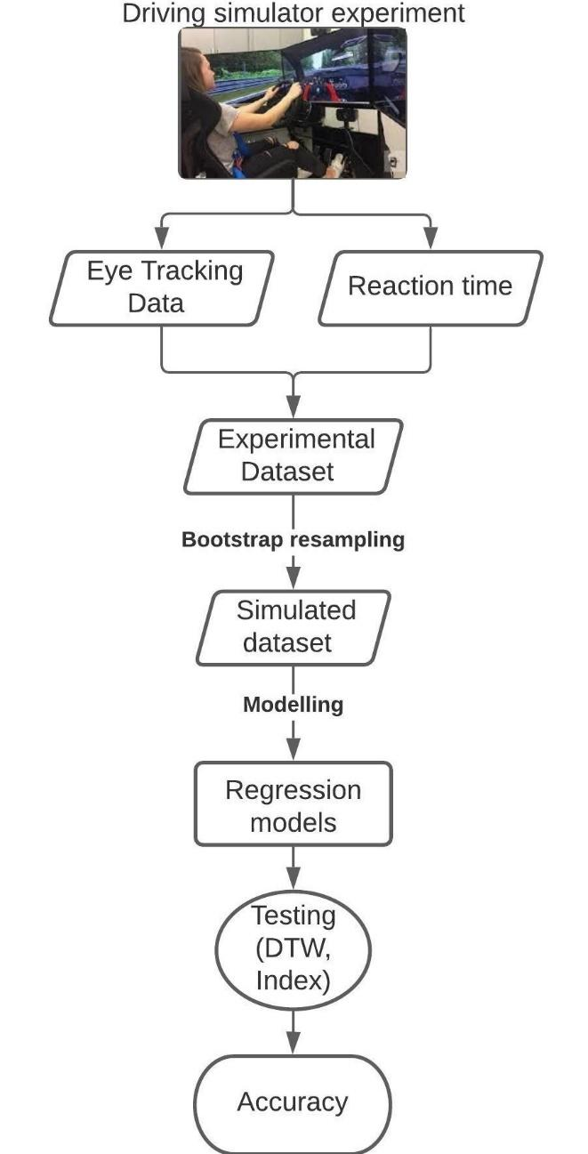

Fig 1: This figure denotes the schema of the study. In this study, experimental data was taken from a virtual reality driving simulator experiment and that data was simulated using bootstrapping method. That simulated data was used to model different regression models and those models were tested using DTW and index mentioned in the evaluation section for accuracy.

**II. Regression Analysis:**

**1) Linear regression model-**

In this model, we provide some observed data and get a 'best fit' line(hypothesis) to describe the relationship between two variables.

We assume our linear hypothesis to be- $Y= βX+ε$

where Y is predicted output for any value of any feature X,

β and ε are the parameters that need to be optimized by using Gradient descent.

**2) Polynomial regression model-**

In this model, we provide some observed data and get a 'best fit' polynomial hypothesis to describe the relationship between the independent and dependent variables in the form.

In our case, we used a quadratic polynomial regression.

We assume our polynomial hypothesis to be-

$Y= \sum_{i =1}^{m}{}β_{i}X^{i}+ ε$

Where “Y” is our expected output for any value of a feature “X”,

All the β1, β2 and ε are the parameters that need to be optimized by using Gradient descent.

**3)Support Vector Regression (SVR)-**

Unlike a SVM classifier, instead of being used for binary classification, SVR aims to estimate a continuous value and it is characterized by the use of kernels.

In our case, linear, polynomial and radial basis function (RBF) kernel parameters are used for SVR.

The formula is stated as- $Y=wX+b$

Where “w” is the weight and “b” is the bias.

If the data is not linearly separable, slack variables (ξ) are added to the model. In the case, the predicted value Y is more than a certain distance ε from the actual value, a penalty factor C is included.

The error function E can be stated as –

$E=C\sum_{i=1}^{L}{}\left(ξ^{+}+ ξ^{-}\right)+ \frac{1}{2} w^{2}$

**4)Partial least squares regression (PLSR):**

Partial least squares (PLS) regression is a technique that reduces the predictors to a smaller set of uncorrelated components and performs least squares regression on these components, instead of on the original data

**5) Artificial neural network (ANN):**

Regression ANNs predict an output variable as a function of the inputs. The input features (independent variables) can be categorical or numeric types, however, for regression ANNs, we require a numeric dependent variable. The activation function used in input and hidden layers is a rectified linear unit function (RELU) and activation function used in output layer is linear as the model is used to predict numerical data.

**III. Evaluation:**

Regression models used for the study were evaluated using two metrics, one is a new metric, an Index which is a logarithm of the ratio of Pearson's correlation coefficient (r) to the final Mean squared error value (MSE) of the model. In general, the more accurate the model, the value of r will be near to 1 as the range of r is from -1 to 1. The MSE value will also be much less than 1 if the model is more accurate. Hence the index, which is the logarithm of the ratio r and MSE will be much greater than 1 if the model is more accurate.

**Pearson’s correlation coefficient:**

Pearson's correlation coefficient (r) is a measure of the strength of the association between the two variables.

The mathematical expression of the Pearson’s correlation coefficient between experimental observations and model predicted values is:

$r\left(y,\hat{y}\right)= \frac{\sum_{i=1}^{N}{}(y_{i}-\underline{y})({\hat{y}}_{i }- \underline{\hat{y}})}{\sqrt{\sum_{i=1}^{N}{}{(y_{i}-\underline{y})}^{2}\sum_{i=1}^{N}{}{({\hat{y}}_{i }- \underline{\hat{y}})}^{2}}}$

Where $\hat{y}$, y are the observed values and predicted values of reaction time, and $\underline{\hat{y}}$, $\underline{y}$ are the mean of observed values and mean of predicted values of reaction time.

**Mean squared error:**

Mean Squared error is the average squared distance between the estimated values and the observed values. Smaller the MSE, means more accurate the model.

The mathematical expression of the MSE is given by:

$MSE\left(y,\hat{y}\right)= \frac{1}{N} \sum_{i=1}^{N}{}{(y_{i}- {\hat{y}}_{i})}^{2}$

Where $\hat{y}$, y are the observed values and predicted values of reaction time

The second metric used to evaluate the regression models used is Dynamic Time Warping (DTW). It was first used for and has a wide application in time series signals and speech recognition. It is used to calculate the alignment or similarity of two time series signals or speech patterns. The points on two signals were aligned flexibly to find the optimal alignment between them. The optimal alignment cost of points i, j on two signals was calculated by measuring the distance between them and the minimal cost of previously aligned points of two signals. It can be represented as:

$DTW\left[i,j\right]=cost\left[i,j\right]+min⁡(DTW\left[i-1,j\right], DTW\left[i,j-1\right], DTW\left[i-1.j-1\right])$

$Cost\left[i,j\right]=dist[i,j]$

DTW was considered as a similarity measure in this study to estimated fatigue level using regression output and actual fatigue level considered as reaction time (20). The lower the value of DTW, greater the similarity between estimated fatigue level and the actual fatigue level. DTW are of four types depending on time taken for computation are FASTDTW, DTW, SPARSEDTW, CDTW. Although all of them lead to approximately the same result but FASTDTW will take very less time compared to DTW, CDTW and SPARSE DTW. In this study FASTDTW was used to calculate the similarity between predicted mental fatigue level to the actual mental fatigue level. By using both the metrics, DTW and index, performance of the models can be predicted accurately.

**Results:**

Estimation of mental fatigue while driving was done using above mentioned regression models. After exploring the observations and results of regression models, Polynomial regression was found to give the maximum performance with R2 score of 1.0, which means the accuracy of the polynomial regression model on the test set was found to be 100% and it has a DTW value of 9.79E-12 which is very less than the DTW values of other models. From these results, we can say that the mental fatigue level estimated by the polynomial regression model is most similar to the actual mental fatigue level, hence more accurate.

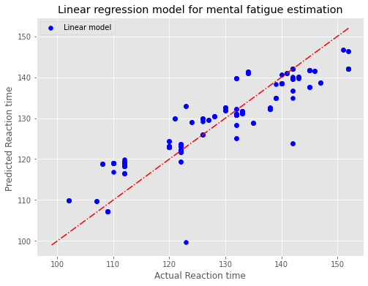

Fig 2: This is the plot of experimental reaction time (RT) values to the predicted reaction time values for Linear regression model. Here the red dotted line corresponds to points on which experimental RT values are equal to the predicted RT values and Blue dots are the predicted RT value for corresponding experimental RT value.

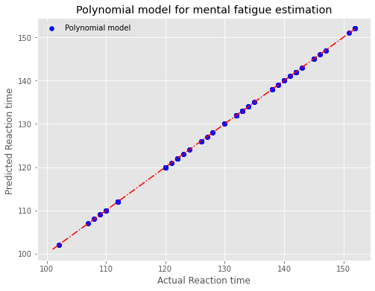

Fig 3: This is the plot of experimental reaction time (RT) values to the predicted reaction time values for Polynomial regression with degree three model. Here the red dotted line corresponds to points on which experimental RT values are equal to the predicted RT values and Blue dots are the predicted RT value for corresponding experimental RT value.

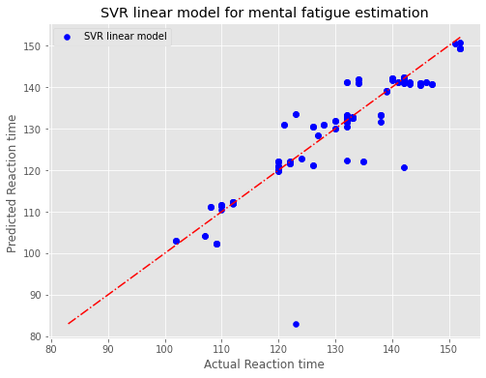

Fig 4: This is the plot of experimental reaction time (RT) values to the predicted reaction time values for Support vector regression model with Linear kernel. Here the red dotted line corresponds to points on which experimental RT values are equal to the predicted RT values and Blue dots are the predicted RT value for corresponding experimental RT value.

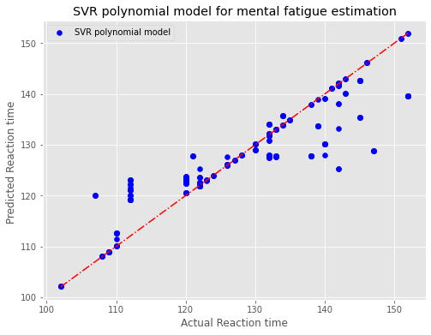

Fig 5: This is the plot of experimental reaction time (RT) values to the predicted reaction time values for Support vector regression model with Polynomial kernel. Here the red dotted line corresponds to points on which experimental RT values are equal to the predicted RT values and Blue dots are the predicted RT value for corresponding experimental RT value.

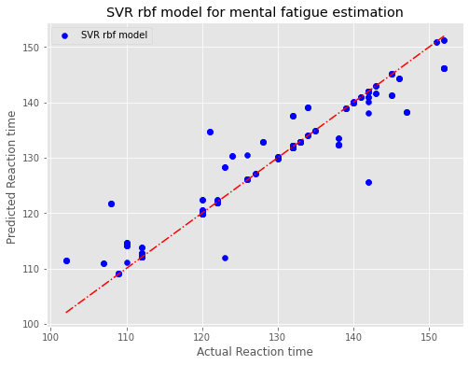

Fig 6: This is the plot of experimental reaction time (RT) values to the predicted reaction time values for Support vector regression model with radial basis function kernel. Here the red dotted line corresponds to points on which experimental RT values are equal to the predicted RT values and Blue dots are the predicted RT value for corresponding experimental RT value.

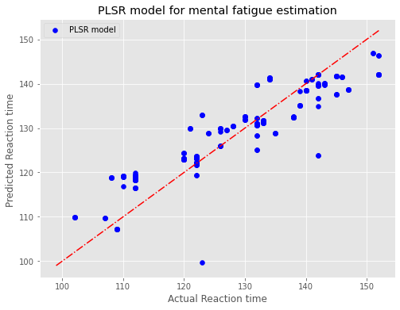

Fig 7: This is the plot of experimental reaction time (RT) values to the predicted reaction time values for Partial least squares regression model. Here the red dotted line corresponds to points on which experimental RT values are equal to the predicted RT values and Blue dots are the predicted RT value for corresponding experimental RT value.

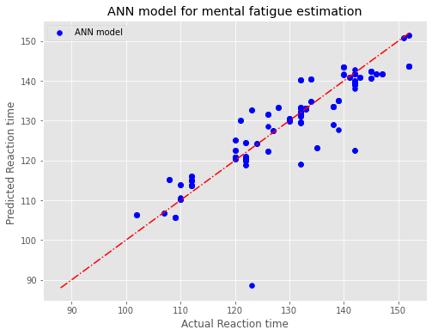

Fig 7: This is the plot of experimental reaction time (RT) values to the predicted reaction time values for Artificial Neural Network (ANN) regression model. Here the red dotted line corresponds to points on which experimental RT values are equal to the predicted RT values and Blue dots are the predicted RT value for corresponding experimental RT value.

|  |  |  |  |
| --- | --- | --- | --- |
| **Regression model** | **R2 score** | **MSE** | **Mean absolute error** |
| Linear | 0.811277562 | 29.90614903 | 4.268874263 |
| Polynomial deg 2 | 1 | 6.70E-24 | 5.44E-14 |
| Polynomial deg 3 | 1 | 3.87E-27 | 3.50E-14 |
| Polynomial deg 4 | 1 | 5.77E-26 | 1.03E-13 |
| SVR linear | 0.85157885 | 23.5197526 | 2.714630524 |
| SVR Polynomial | 0.796935194 | 32.17893121 | 3.433249694 |
| SVR rbf | 0.887413756 | 17.84112702 | 2.119085174 |
| PLSR | 0.81145903 | 29.87739254 | 4.268650867 |
| ANN | 0.815272403 | 29.2731014 | 3.321693202 |

Table 1: This table contains the R2 Scores, Mean squared error (MSE) values and Mean absolute error values of corresponding regression models on the test set.

|  |  |  |
| --- | --- | --- |
| **Model** | **Index** | **DTW** |
| Linear | -3.4851 | 1153.933282 |
| Polynomial | 4.89417 | 9.79E-12 |
| SVR Linear | -3.2344 | 693.0171353 |
| SVR Polynomial | -3.562 | 914.4171569 |
| SVR RBF | -2.8701 | 556.7471733 |
| PLS | -3.4847 | 1153.837291 |
| ANN | -3.3143 | 862.1200943 |

Table 2: The table of Regression models with respective Index values and DTW values.

|  |  |  |  |  |
| --- | --- | --- | --- | --- |
|  | **Euclidean/Manhattan** | | **Squared Euclidean** | |
| **Regression model** | **FastDTW** | **DTW** | **FastDTW** | **DTW** |
| Linear | 1153.933282 | 1153.933282 | 7448.941537 | 7448.941537 |
| Polynomial deg 2 | 1.52E-11 | 1.52E-11 | 1.43E-24 | 1.43E-24 |
| Polynomial deg 3 | 9.79E-12 | 9.79E-12 | 5.65E-25 | 5.65E-25 |
| Polynomial deg 4 | 2.87E-11 | 2.87E-11 | 5.42E-24 | 5.42E-24 |
| SVR linear | 693.0171353 | 693.0171353 | 5233.993267 | 5233.993267 |
| SVR Polynomial | 914.4171569 | 914.4171569 | 9570.759534 | 7281.347724 |
| SVR rbf | 556.7471733 | 556.7471733 | 3744.734038 | 3744.734038 |
| PLSR | 1153.837291 | 1153.837291 | 7443.361852 | 7443.361852 |
| ANN | 862.1200943 | 862.1200943 | 5160.758842 | 5160.758842 |

Table 3: The table of FastDTW and DTW values of different regression models calculated using possible distance functions

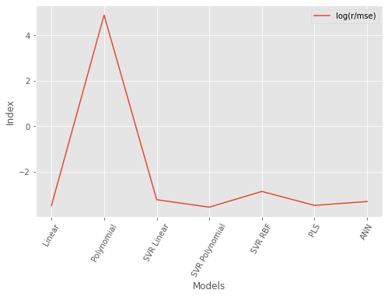

Fig 8: This plot corresponds to the comparison of performance by using the metric index which is the ratio of r to the MSE.

From fig 2 and table 1, it is clear that the Polynomial regression model is giving the maximum performance for the eye tracking dataset used in this study. As the polynomial regression model is much simpler in terms of computation and complexity, it can be used for practical implementations of estimating fatigue efficiently. By further studies on polynomial regression it was observed that the polynomial regression model with degree three was observed to have the minimum mean squared error (MSE) value of 3.88x10-27 with R2 score of 1.0 which implies it has the maximum performance at degree three. Two metrics were employed in this study to efficiently find the model with the best performance and the maximum accuracy. Since the MSE value of polynomial regression models is much less than 1, a new metric was employed to find the model with maximum performance and the new metric is the logarithm of the ratio of Pearson’s correlation coefficient (r) to the Mean squared error (MSE) value. Along with this, DTW was used to test models for accuracy. The index value and DTW values of the polynomial regression model was observed to be the best from table 2. From these findings it can be concluded that polynomial regression best is for Mental fatigue estimation which has non-linear features and has best performance compared to higher and complicated models like ANN model, PLSR model.

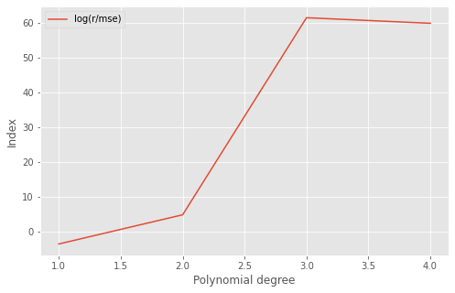

Fig 9: Comparison of the Indexes of Linear regression model (Polynomial regression model with degree 1) and polynomial model with degree up to which computation is feasible (degree four).

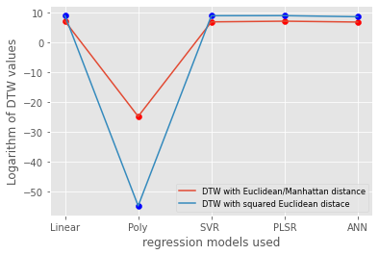

Fig 10: Comparison of the Logarithm of DTW values of different Regression models calculated using Euclidean, Manhattan and Squared Euclidean distances.

Apart from this correlation analysis has shown that only 8 of all 15 features seem to be contributing for the prediction of reaction time. From the correlation analysis, it was observed that columns of Fixation Duration, Hs, Ht, FSR, P, E, FR and TWL are the most contributing features for the estimation of reaction time.

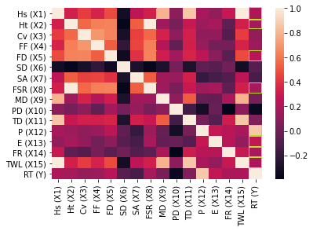

Fig 11: Correlation heatmap of Experimental data. Features which have high correlation with reaction time (y) were bordered with green colour.

Among those 8 contributing features, P was the most contributing feature which can be observed from correlation heatmap in fig 11. As the results are promising with reliable quality scores (R2 score, MSE, MAE), these findings can be used for further study.

**Discussions:**

This study is to estimate mental fatigue effectively by using non-complex and feasible models to compute regression models because more complex models will increase the computational time due to which there will be lag in recording the reaction time. The scenario of driving was considered for this study because in the majority of the cases mental fatigue has a great impact on the road accidents recorded per year, Person experiencing the mental fatigue while driving may not only injure themselves but also injure others as well.

In this study, we created a three-window driving simulation and tested on 21 persons.  The experimental data of eye tracking along with corresponding reaction times was recorded using a Virtual Reality (VR) driving game using an eye tracker from Tobiipro named Tobii Pro Eye Glasses 2. Since the data available was limited and regressions models need a lot of data to train, which increases the accuracy of the model. Simulated data was created based on experimental data. Bootstrap resampling method was used to simulate the experimental data to increase the size of the data.

Regression models used for the modelling of data were Linear regression model, Polynomial regression model, Support vector regression model, Partial least squares regression, Artificial neural network regression models. Among these models, Polynomial regression models seem to exhibit the best performance. It was observed from fig 3 and table 1, that polynomial regression models have R2 of 1.0 for all the possible degrees greater than 1. Among those possible degrees, from fig 9 and table 1 we can conclude that a polynomial regression model with degree three has shown the best performance among all other regression models. The regression models were tested using two metrics for accurate results as two step testing is more reliable. The metrics used for testing are DTW and Index and regression models show the same trend in testing results with both the metrics. From this we can say that the results are more promising as they are following the same pattern.

From table 3 and figure 10, It was observed that the values of DTW calculated using Fast DTW and DTW algorithms were almost the same and the exception was observed for SVR model with Polynomial kernel. The only difference between these algorithms is computational time and this is because some of the Algorithms like DTW have their source code in Python where as FastDTW and Dtaidistance have their source codes in C or C++ which make them much more faster then algorithms have source code in python.

Apart from this correlation analysis has shown that only 8 of all 15 features seem to be contributing for the prediction of reaction time. From the correlation analysis, it was observed that columns of Fixation Duration, Hs, Ht, FSR, P, E, FR and TWL are the most contributing features for the estimation of reaction time. Among those 8 contributing features, it was found that the P was the most contributing feature which can be observed from correlation heatmap in fig 10. As the results are promising with reliable quality scores (R2 score, MSE, MAE), these findings can be used for further study. Further study on this topic is necessary, as in real life scenario there will be a lot of other factors available which can affect the mental condition of an individual and demands elaborate experimental paradigms.

**Conclusion:**

In the study, eye tracking data was collected from a VR game system and used to study the effect of these parameters on mental fatigue. Here, the mental fatigue while driving was estimated by various regression models using the eye movement data. The conclusions are as follows:

Among the various parameters of eye tracking data, Fixation Duration, Hs, Ht, FSR, P, E, FR and TWL features are the most contributing features for the estimation of reaction time. Among these features, P has the maximum correlation with the dependent variable reaction time. These observations were used to improve the performance of the regression models by avoiding non relevant features.

Estimation of mental fatigue was performed using five regression models, i.e., Linear regression model, Polynomial regression model, Support vector regression model (SVR), Partial least squares regression model (PLSR). Among these regression models, a Polynomial regression model with degree three was observed to have the high Index value and low DTW value, metrics used to check the performance and accuracy of the regression models.

It is found that the accuracy of polynomial model with degree three which was estimated using R2 score was observed to be 100% and mean squared error (MSE) was observed to be 3.88x10-27 which is much less than 1. From these observations, it was concluded that this model can be used for further study as a lot of other factors will also act on the subject in the real-life scenario.

**References:**

1. Rohit Bose, Hongtao Wang, Andrei Dragomir, and Nitish Thakor, “ *Regression based continuous driving fatigue estimation- a practical implementation*”, IEEE Transactions on Cognitive and Developmental Systems, vol 12, issue 2.

1. Leonard J. Trejo, Karla Kubitz, Roman Rosipal, Rebekah L. Kochavi, Leslie D. Montgomery, “*EEG-Based Estimation and Classification of Mental Fatigue*”, Psychology, 2015, 6, 572-589, Pacific Development and Technology, LLC, Palo Alto, USA

1. Dinges, D. F. (1995). “An Overview of Sleepiness and Accidents”. Journal of Sleep Research, 4, 4-14.

1. Dingus, T. A., Klauer, S. G., Neale, V. L., Petersen, A., Lee, S. E., Sudweeks, J., Perez, M. A., Hankey, J., Ramsey, D., Gupta, S., Bucher, C., Doerzaph, Z. R. , Jermeland, J., & Knipling, R. R. (2006). The 100-Car Naturalistic Driving Study, Phase ii—Results of the 100-Car Field Experiment Performed by Virginia Tech Transportation Institute, Blacksburg, VA, Spon-sored by National Highway Traffic Safety Administration, Washington DC, April 2006, DOT HS 810 593 - April 2006.

1. C. Zhao, C. Zheng, M. Zhao, Y. Tu, and J. Liu, "Multivariate autoregressive models and kernel learning algorithms for classifying driving mental fatigue based on electroencephalographic," *Expert Systems with Applications,* vol. 38, pp. 1859-1865, 2011.

1. C.-T. Lin, R.-C. Wu, T.-P. Jung, S.-F. Liang, and T.-Y. Huang, "Estimating driving performance based on EEG spectrum analysis," *EURASIP Journal on Applied Signal Processing,* vol. 2005, pp. 3165-3174, 2005.

1. E. Grandjean, "Fatigue in industry," *Occupational and Environmental Medicine,* vol. 36, pp. 175-186, 1979.

1. S. K. Lal and A. Craig, "A critical review of the psychophysiology of driver fatigue," *Biological psychology,* vol. 55, pp. 173-194, 2001.

1. L. Fletcher, N. Apostoloff, L. Petersson, and A. Zelinsky, "Vision in and out of vehicles," *IEEE Intelligent Systems,* vol. 18, pp. 12-17, 2003.

1. P. Smith, M. Shah, and N. da Vitoria Lobo, “Monitoring head/eye motion for driver alertness with one camera,” in Proc.15th International Conference on Pattern Recognition (ICPR ’00), vol. 4, pp. 636–642, Barcelona, Spain, September 2000.

1. C. A. Perez, A. Palma, C. A. Holzmann, and C. Pena, “Face and eye tracking algorithm based on digital image processing,” in Proc. IEEE International Conference on Systems, Man, and Cybernetics (SMC ’01), vol. 2, pp. 1178–1183, Tucson, Ariz, USA, October 2001.

1. J. A. Stern, D. Boyer, and D. Schroeder, “Blink rate: a possible measure of fatigue,” Human Factors, vol. 36, no. 2, pp. 285– 297, 1994.

1. Jie Wei, Tong Chen, Guangyuan Liu, Jiemin Yang, “Higher order multivariable polynomial regression to estimate human affective states”, Scientific reports, vol 6, Southwest University, Chongqing, 400715, China, march 2016.

1. D. Schmidt, L. A. Abel, L. F. Dell’Osso, and R. B. Daroff, “Saccadic velocity characteristics: intrinsic variability and fatigue,” Aviation, Space and Environmental Medicine, vol. 50, no. 4, pp. 393–395, 1979.

1. D. K. McGregor and J. A. Stern, “Time on task and blink effects on saccade duration,” Ergonomics, vol. 39, no. 4, pp. 649– 660, 1996.

1. T. L. Morris and J. C. Miller, “Electrooculographic and performance indices of fatigue during simulated flight,” Biological Psychology, vol. 42, no. 3, pp. 343–360, 1996.

1. K. Van Orden, W. Limbert, S. Makeig, and T.-P. Jung, “Eye activity correlates of workload during a visualspatial memory task,” Human Factors, vol. 43, no. 1, pp. 111–121, 2001.

1. T.-P. Jung, S. Makeig, M. Stensmo, and T. J. Sejnowski, “Estimating alertness from the EEG power spectrum,” IEEE Trans. Biomed. Eng., vol. 44, no. 1, pp. 60–69, 1997.

1. A. Craig, Y. Tran, N. Wijesuriya, and H. Nguyen, "Regional brain wave activity changes associated with fatigue," *Psychophysiology,* vol. 49, pp. 574-582, 2012.

1. Aach J, Church G (2001), “*Aligning gene expression time series with time warping algorithms*”. Bioinformatics 17:495–508